Part Number: PT747-1M160
Kit Contents
Item # | Quantity Reqd. | Description
1 | 1 | Applique, RR Bumper
2
3
Hardware Bag Contents
Item # | Quantity Reqd. | Description
1
2
3
Additional Items Required For Installation
Item # | Quantity Reqd. | Description
1
2
3
Conflicts
None
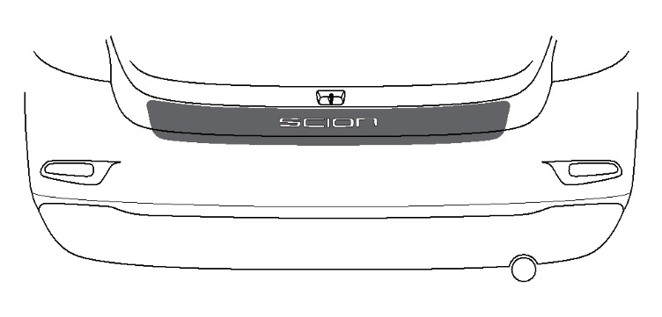
Recommended Tools
Care must be taken when installing this accessory to ensure damage does not occur to the vehicle. The installation of this accessory should follow approved guidelines to ensure a quality installation.

These guidelines can be found in the "Accessory
Installation Practices" document.

This document covers such items as:-
• Vehicle Protection (use of covers and blankets, cleaning chemicals, etc.).
• Safety (eye protection, rechecking torque procedure, etc.).
• Vehicle Disassembly/Reassembly (panel removal, part storage, etc.).
• Electrical Component Disassembly/Reassembly (battery disconnection, connector removal, etc.).

Please see your Scion dealer for a copy of this document.

Personal & Vehicle Protection | Notes
None
Special Tools | Notes
Squeegee | 4" (3M™Gold) or  4" (3M™Silver)
Low Friction Sleeve | 3M SA-1 (OPTIONAL)
Surface Thermometer | Infrared Non-contact
Heat Gun | Master Heat Gun HG-301A or equivalent
Installation Tools | Notes
Lint Free Rags
Spray Bottle | For wetting agent
Special Chemicals | Notes
Cleaner | Simple soap & water solution
Wetting Agent  Note: Solution depends upon ambient temperature of the part and the vehicle surface. If it is difficult to remove bubbles with a squeegee, add one more ml. of shampoo. | Johnson’s Baby Shampoo mixed in one liter of water:  At 65˚F add 2 ml. shampoo  At 70˚F add 3 ml. shampoo  At 80˚F add 3.5 ml shampoo At 90˚F add 4 ml. shampoo
General Applicability
All iA models
Recommended Sequence of Application
Item # | Accessory
*Mandatory
Vehicle Service Parts (may be required for reassembly)
Item # | Quantity Reqd. | Description
Legend
STOP: Damage to the vehicle may occur. Do not proceed until process has been complied with.
OPERATOR SAFETY: Use caution to avoid risk of injury.
CAUTION: A process that must be carefully observed in order to reduce the risk of damage to the accessory/vehicle and to ensure a quality installation.
TOOLS & EQUIPMENT: Used in Figures calls out the specific tools and equipment recommended for this process.
REVISION MARK: This mark highlights a change in installation with respect to previous issue.
SAFETY TORQUE: This mark indicates that torque is related to safety.
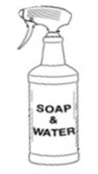
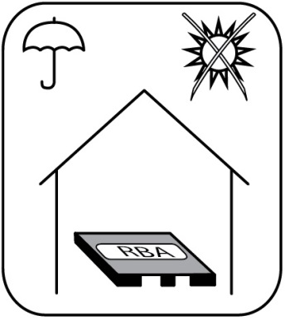
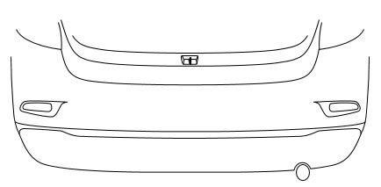
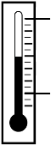
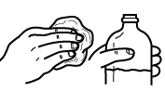
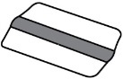
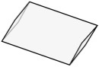
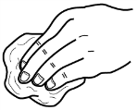
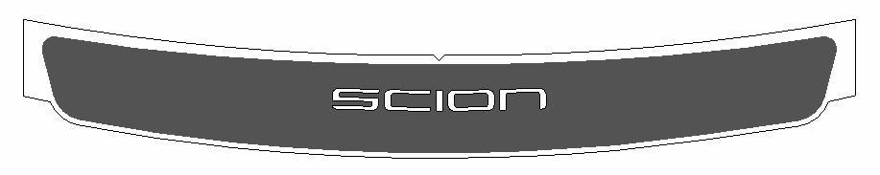
Storage
90˚F

OK

65˚F

Installation Temperature
Cleaner
Squeegee
Sleeve (Optional)
Lint Free
Rear Bumper Applique
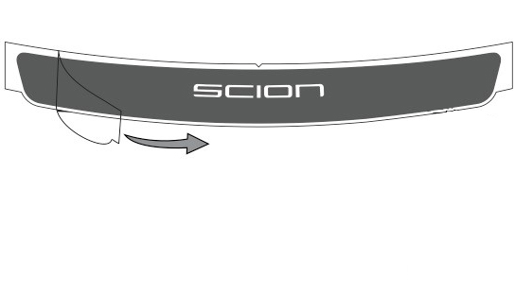
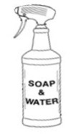
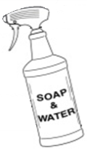
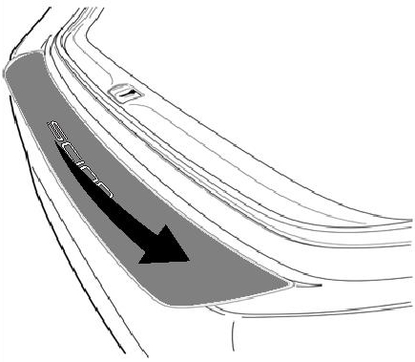
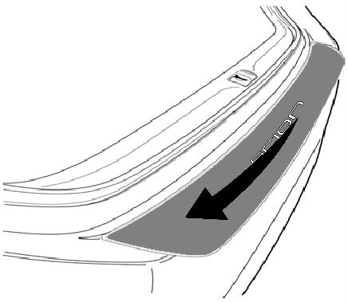
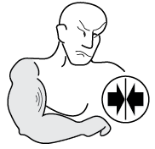
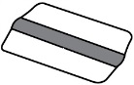
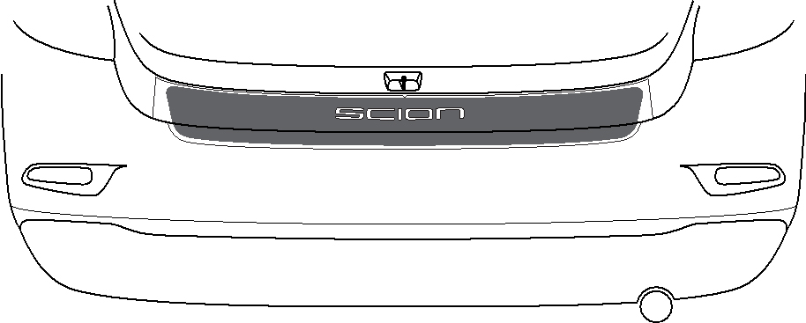
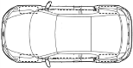
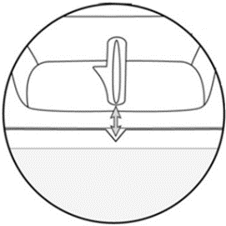
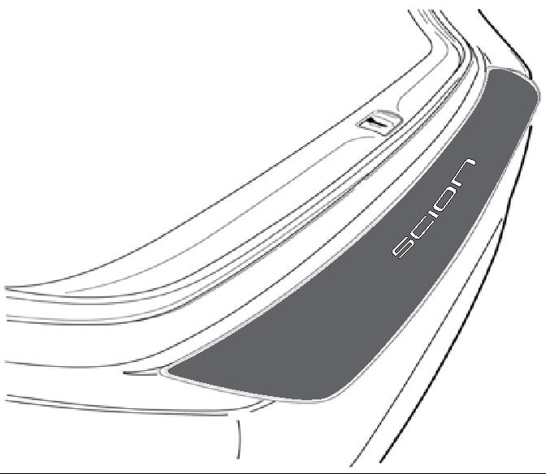
3
2
1
CLEAN
a
DRY
b
6

SQUEEGE

SQUEEGE
5

ALIGN
4

ALIGN
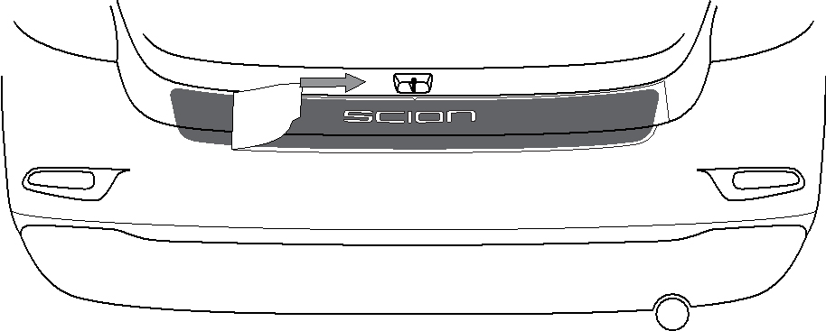
7
180°

PULL

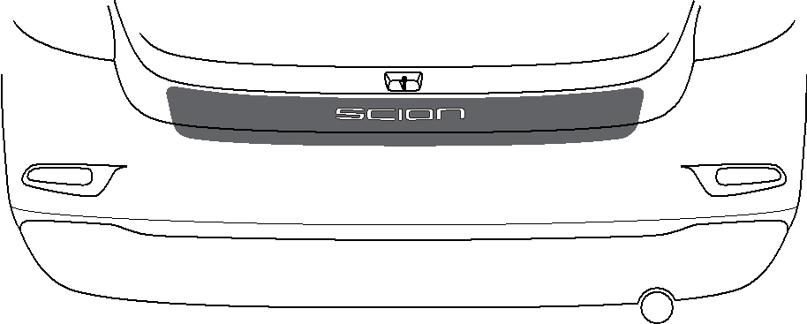
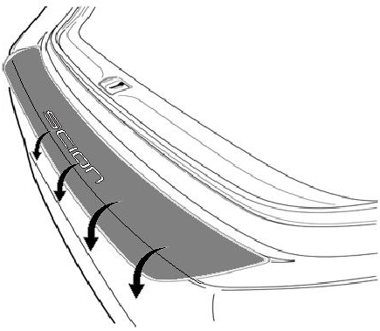
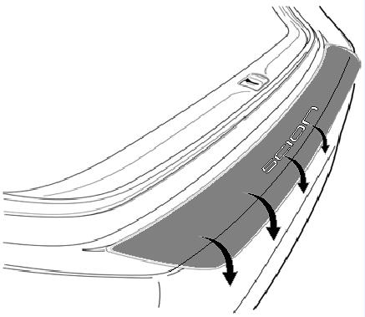
9
DRY
8
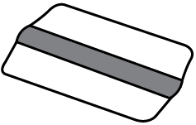

SQUEEGEE
= OPTIONAL

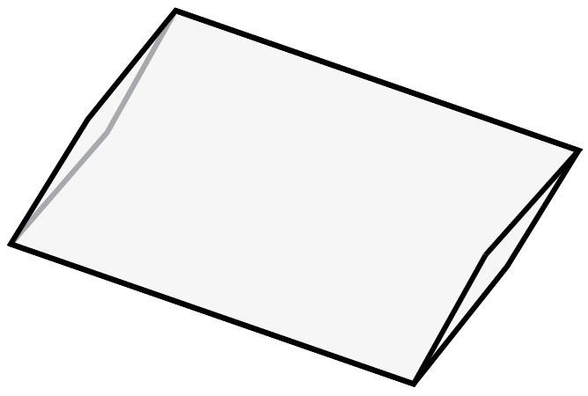
SLEEVE

SQUEEGEE
7
6
4
3
2
8
1
5

Accessory Function Checks
Proper adhesion – Visual

Proper adhesion – Physical

Proper alignment – Cross-Car

Vehicle Appearance Check
After accessory installation and removal of protective cover(s), perform a visual inspection.

Look for bubbles, loose and lifting edges.
Confirm center of “O” is aligned
With light pressure, rub hand over top of part and if crackling sound occurs, re-squeegee. If bubbles cannot be worked out to the nearest edge, replace part.

Part must be centered within bumper +/-3 mm.

Ensure no damage (including scuffs and scratches) was caused during the installation process.
(For PPO installations, refer to TMS Accessory Quality Shipping Standard.)

